Casey First Christian Church (Disciples of Christ)
200 SE 8th St. · P.O. Box 303 · Casey, IL 62420
(217)932-2773 · cfcc@caseyfcc.org · www.caseyfcc.org
Pastor Jaret Alvis, Phone # 217-294-1043
Office Hours: Monday, Wednesday & Friday 8:30 am-Noon
Sunday Services: 8:00 am Worship
Worship service is also live at 8:00 am on Facebook

To Know God-To Love God-To Serve God

Prayer Requests
Barb Decker Sharon Durham Kevin-Peggy Waller’s Nephew
Randy Rue Kenny Shobe Doris Taylor
Bill Weaver

Our Sympathy and Condolences to the following families that have lost loved ones since the last newsletter.

Family of Clifford Kibler-Nina Meeker’s Uncle

JOYS

Taylor Stifal passed her boards and is a Certified Nursing Assistant
John & Tayelar Hayes are expecting a baby boy

Casey Health Care Heartland Nursing Simple Blessings
Ruth Fitch & Rehabilitation Ramona Miller
Vera Ingle
Arbor Rose Memory Care Helen Allen
Brenda Whitton

Please reach out to your Elder with any questions, concerns or needs.

ELDERS
Sherri Butcher – 217-232-5740 Sharon Durham – 217-932-2164
Kathy Hayes – 217-932-3626 Peggy Hickox – 217-232-5615
Larry Patchett – 217-232-3105 Debi Sinclair – 217-932-6104
Moe Wimbley – 217-932-2829 Ruthie Wimbley – 217-232-1949
Dan Winn – 217-259-5339 Church Office – 217-932-2773

Announcements & Upcoming Events

Thursday, November 26th – THANKSGIVING DAY OFFICE CLOSED
Friday, November 27th – CHURCH OFFICE CLOSED
Wednesday, December 2nd – Board Meeting 7:00 pm
Monday, December 14th – Worship Team Meeting 9:30 am
Monday, December 14th – Preparing bags for the food pantry, See Marcia for details
Tuesday, December 15th – Handing our Food Pantry bags

Our Daily Bread devotionals for Dec. 2020 thru Feb. 2021 are in the Gathering Room. If you are not able to pick one up and would like one mailed to you please give the office a call.

We restocked our supply of RADA Cutlery. These make very nice gifts for Christmas, weddings, anniversaries and birthdays, or just for yourself. Contact the office if you are interested in purchasing an item.

Special offering for the Food Pantry. Starting next Sunday we will be taking a special offering for the Food Pantry. We are doing the monetary offering instead of the normal food drive due to the COVID19 situation. The food drive is able to purchase items at special prices so your monetary donation might go further anyway. Be in prayer to give what you can. We have lots of families in need in our community. Our church will be in charge of the food pantry for December. We will be bagging groceries on Monday, Dec. 14th and handing them out Dec. 15th.
We will be taking orders for Poinsettias to decorate the sanctuary for the Christmas season. They will be available in two sizes as in the years past. There will be an insert in the bulletin next week for you to order with the details. If you would like to order one fill out the insert or call the church office for details. We need payment with your order.

Special Thanksgiving Offering. The insert below shows where your offering goes. We know we have many that are attending church virtually and we want to include you in the opportunity to give to this offering. Just mail your offering to the church with a memo “Thanksgiving Offering”. The church matches your offering. Thank you!

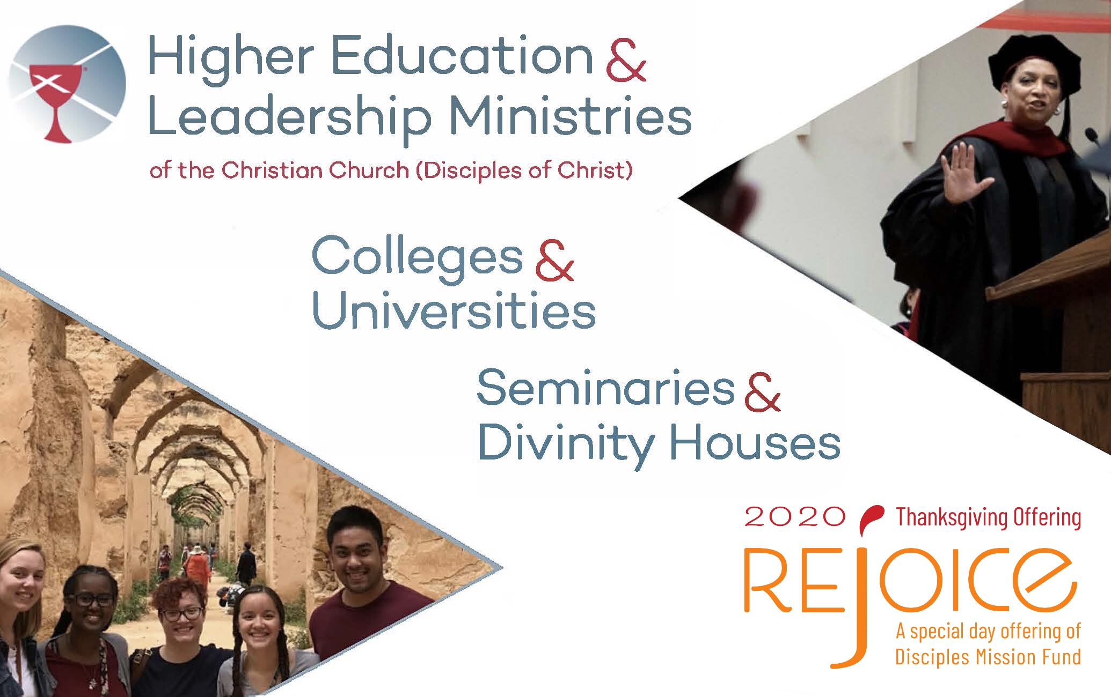

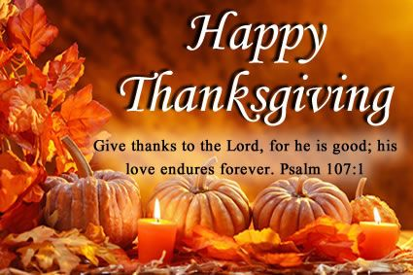

DECEMBER 2020

1 – Blake Ramsey 16 – Ed & Marge Allen
2 – Ed Allen 19 – Curt Wheat
4 – Marge Allen 23 – Randy & Rebecca Daugherty
7 – Kenny Whitton 27 – Audrey Sherwood
7 – Dan Winn 28 – Carole Cutright
10 – Gene Whitton 30 – Kyleigh Decker
14 – Moe Wimbley 30 – Olive Athey

 | December 2020
Sunday | Monday | Tuesday | Wednesday | Thursday | Friday | Saturday
 |  | 1 | 2  Board Meeting 7:00 pm | 3 | 4 | 5
6  Worship 8:00 am  Elder:  Ruthie Wimbley | 7 | 8 | 9 | 10 | 11 | 12
13  Worship 8:00 am  Elder:  Dan Winn | 14  Worship Team Mtg.  9:30 am  PREPARE FOOD PANTRY BAGS | 15  HAND OUT FOOD PANTRY BAGS | 16 | 17 | 18 | 19
20  Worship 8:00 am  Elder:  Sherri Butcher | 21 | 22 | 23 | 24 | 25 | 26
27  Worship 8:00 am  Elder:  Sharon Durham | 28 | 29 | 30  Elders Meeting 6:30 pm | 31
MML – Monday Morning Ladies
FH – Fellowship Hall
SUNDAYS
8:00 am Worship, 9:30 am Sunday School

