Casey First Christian Church (Disciples of Christ)
200 SE 8th St. · P.O. Box 303 · Casey, IL 62420
(217)932-2773 · cfcc@caseyfcc.org · www.caseyfcc.org

Sunday Services: 9:00 am Sunday School · 10:00 am Worship

To Know God-To Love God-To Serve God

SERVING SCHEDULE
 | Week  9/1/2019 | Week  9/8/2019 | Week  9/15/2019 | Week  9/22/2019 | Week  9/29/2019
ELDERS | Worship in the Park | Debi Sinclair | Dan Winn | Sharon Durham | Nina Meeker
ELDERS SHUT-INS
DEACONS |  | Brad Hickox  Charles Meeker  Cassie Ramsey | Sharon Richardson  Connie Roberts  Shellie Simpson | Kenny Shobe  Steph Shobe  Devan Smith | Cheryl Stifal  Jeanne Unzicker  Jeri Bland
PREP. COMM. |  | Brad & Charles | Sharon & Connie | Kenny & Steph | Cheryl & Jeanne
DEACONS SHUT-INS
WORSHIP LEADER |  |  |  | Cassie Ramsey | Larry Patchett
GREETER |  |  | Cassie & Owen Ramsey |  | Peggy Hickox
SOUND |  | Devan Smith | Ken Whitton | Chelsea Clapp | Brad Hickox
CHILDREN'S MESSAGE |  | Rev. Mike | Rev. Mike |  | Rev. Mike
CHALLENGER REFRESHMENTS |  | Linda Coleman | Sharon Durham | Grahams | Peggy Hickox
SERMON |  | Rev. Mike | Rev. Mike | Rev. Rebecca | Rev. Mike
PLEASE FIND A REPLACEMENT IF YOU ARE NOT ABLE TO SERVE.

Prayer Requests
Rex Bland
Family of John Chapman
Becky Daugherty
Family of Stephen Davis
Shirley Fitch
Family of Frances Hickox
Liza Marie Johnson – Baby Daughter of Andy & Kelly Johnson, Granddaughter of Mike & Cathy Sherwood
Lawrence McKinney
Wanda McNary
Randy Rue
Dave Sauer

A Special Prayer for our children and all the staff at all the schools as they return to school for another year. Where did the summer go!

Our Sympathy and Condolences to the following families that lost loved ones this past month.

Jack Connelly Family
Jerry Nichols Family
Stephanie Markwell Family
John Chapman Family
Frances Hickox Family
Lee Markwell Family

Casey Health Care Heartland Nursing Active Military
Ruth Fitch & Rehabilitation Brandon Blair
Vera Ingle Daniel Daugherty
Arbor Rose Memory Care Helen Allen Tyler Rue
Brenda Whitton

JOYS

Gene Vidoni was chosen as Honorary Chairperson of the 69th Annual Casey Open Golf Tournament held
July 27th & 28th &
50 years ago Gene was hired by
Casey High School
as assistant coach to Bob Durham.

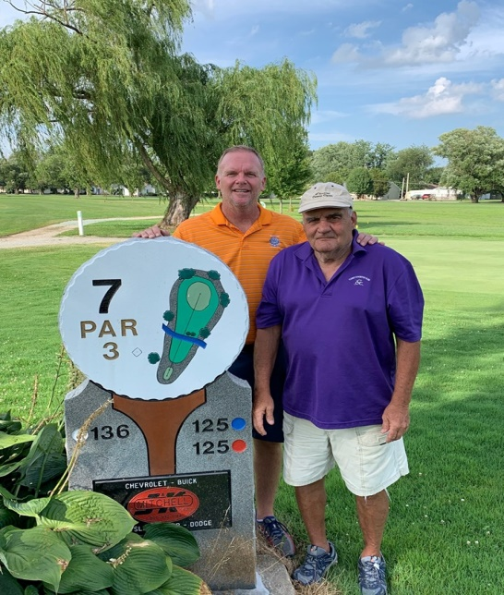

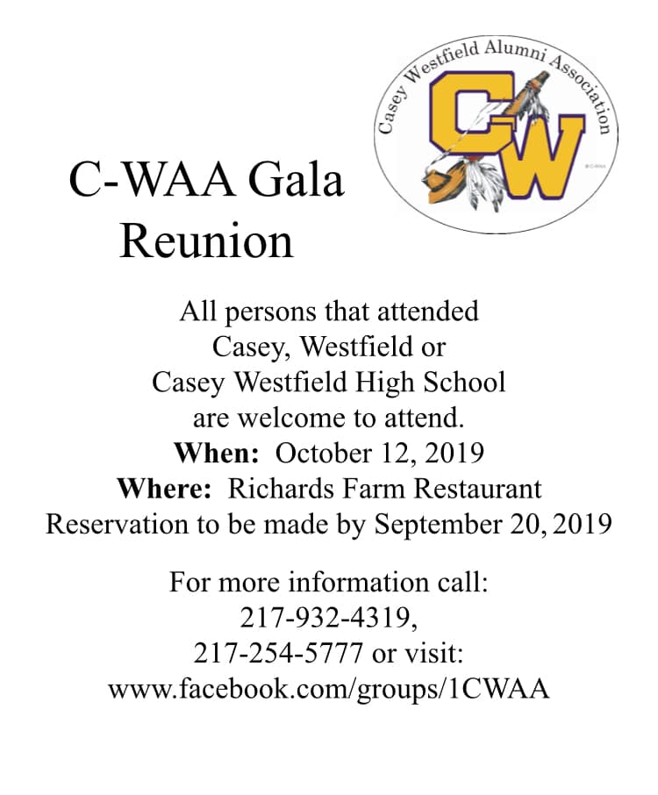

Announcements & Upcoming Events

GIVE A BOX OF KLEENEX
Thank you for your generous outpouring of Kleenex for the Monroe students and teachers. I didn’t count the boxes but we donated a BUNCH. They were delivered to the school Tuesday, August 13th and they really appreciated it.

POPCORN FESTIVAL
Saturday Aug. 31 – Monday Sept. 2
The church is having a booth again this year at the festival. We are in need of homemade pies and workers. A sign-up sheet is being circulated. Please help if you can.

IGA COOKOUT FUNDRAISER
Saturday, Sept. 14
11:00 am-1:00 pm
Watch for sign-up sheet to help.

ACTIVITIES IN THE CHURCH

Aug 25 After worship Back to School Lunch
Aug 28 7:00 pm Elders Meeting
Aug 31-Sep 2 Popcorn Festival
Sep 2 LABOR DAY-CHURCH OFFICE CLOSED
Sep 4 7:00 pm Board Meeting
Sep 11 9:30 am Worship Team Meeting
Sep 11 6:30 pm Dinner & A Prayer (Watch for details)
Sep 14 11:00 am – 1:00 pm IGA Cook Out Fundraiser
Sep 25 7:00 pm Elders Meeting
Oct 2 7:00 pm Board Meeting
Oct 14 COLUMBUS DAY-CHURCH OFFICE CLOSED

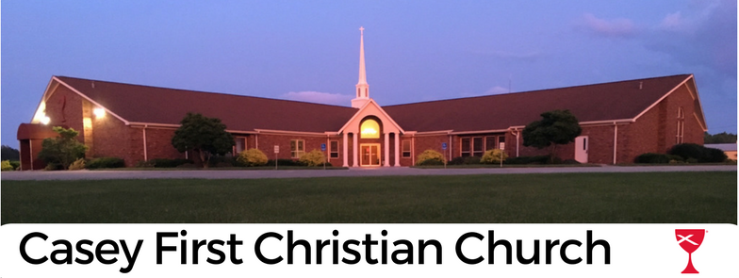

September 2019

3 – Donna Nichols 11 – Shirley Fitch
3 – Debi Sinclair 11 – Wren Roberts
5 – Connie Roberts 13 – Rhett Athey
5 – Tyler Bland 16 – Bonnie McCash
5 – Sharon Richardson 17 – Andy & Erin Leichty
5 – John & Cassie Ramsey 18 – Alisha Freeman
6 – Wade Roberts 18 – Mike & Debbie Leichty
7 – Larry Smith 18 – Corey Carver
9 – Daniel Daughert 18 – Jason & Dinah Wimbley
9 – Kenny & Steph Shobe 22 – Bentley Newlin
10 – Shirley Whitton 25 – Grey Gilbert
10 – Chelsea Clapp 30 – Val Endsley

 | September 2019
Sunday | Monday | Tuesday | Wednesday | Thursday | Friday | Saturday
1  10:30 am  Worship in the Park | 2  Labor Day  Church office closed | 3  12-6 pm Blood Drive at 1st Baptist Church | 4  7:00 pm Board Meeting | 5 | 6 | 7
8 | 9  MML  9:00 am | 10 | 11  9:30 am Worship Team Mtg.  6:30 pm Dinner & A Prayer | 12 | 13 | 14  11:00 am – 1:00 pm IGA Cookout Fundraiser
15 | 16  MML  9:00 am | 17 | 18 | 19 | 20 | 21
22  Stewardship Sunday | 23  MML  9:00 am | 24 | 25  7:00 pm Elders Meeting | 26 | 27 | 28
29  Reconciliation Special Offering | 30  MML  9:00 am
MML – Monday Morning Ladies
FH – Fellowship Hall
Sunday School 9:00 am, Worship 10:00 am

