Casey First Christian Church (Disciples of Christ)
200 SE 8th St. · P.O. Box 303 · Casey, IL 62420
(217)932-2773 · cfcc@caseyfcc.org · www.caseyfcc.org
Rev. Jacqueline Morgan, Pastor

Sunday Services: 9:00 am Sunday School · 10:00 am Worship

To Know Him-Love Him-Share Him

_________________________________________________________________________________________
SERVING SCHEDULE
 | August 5th | August 12th | August 19th | August 26th
ELDERS | Kathy Hayes  Nina Meeker | Larry Patchett Cindy Stephen | Debi Sinclair Moe Wimbley | Sherri Butcher Ruthie Wimbley
ELDERS SHUT-INS | Kathy & Nina
DEACONS | Connie Roberts Kenny Shobe  Steph Shobe | Shellie Simpson Devan Smith Cheryl Stifal | Jeanne Unzicker Marcia Vidoni Jeri Bland | Paula Blair Bill Brewer Linda Coleman
PREP. COMM. | Kenny & Steph | Devan & Cheryl | Marcia & Jeri | Bill & Linda
DEACONS SHUT-INS | Cassie & Marcia
WORSHIP  LEADER | Devan Smith | Debi Sinclair | Barb Decker | Peggy Hickox
GREETER | Bill Brewer | Rose Peterson | Cathy Sherwood | Barb Decker
SOUND | Ken Whitton | Michael Stephen | Brad Hickox | Ken Whitton
CHILDREN'S MESSAGE | Moe Wimbley | Patty Clapp |  | Ruthie Wimbley
CHALLENGER REFRESHMENTS | Debi Sinclair | Linda Stoneking | Bill Brewer | Sherri Butcher
SERMON | Pastor Jacqueline | Pastor Jacqueline | Pastor Jacqueline | Pastor Jacqueline

From the pastor’s desk…

When my friends from Texas were here earlier this month, they brought our new hymnals, compliments of the North Texas Area and First Christian Church in Irving, Texas. They also brought me the New Serenity Prayer, which I thought I would share with you.
The New Serenity Prayer
By Fr. James Martin, SJ

God, grant me the serenity to accept the people I cannot change,
which is pretty much everyone, since I’m clearly not you, God.
Al least not the last time I checked.

And while you’re at it, God, please give me the courage
to change what I need to change about myself,
which is frankly a lot, since, once again, I’m not you,
which means I’m not perfect.

It’s better for me to focus on changing myself
than to worry about changing other people,
who, as you’ll no doubt remember me saying, I can’t change anyway.

Finally, give me the wisdom to just shut up
whenever I think that I’m clearly smarter
than everyone else in the room,
that no one knows what they’re talking about except me,
or that I alone have all the answers.

Basically, God, grant me the wisdom to remember that I’m not you.
Amen.

I don’t know about you, but I needed that reminder that I am not God, that I can only change myself, which is already a life-time job, and that I don’t know everything or in my case that my way is not always the best or only way. It is easy to get lost when what is meant to be an inward focus, becomes an outward comparison. When we take the quiet time with God, which will help us to do that hard work on ourselves, and replace it with the quick judgement of ourselves against other people, easily finding faults in the other so we can feel better about ourselves, we not only affect the wellbeing of other people, but we really cheat ourselves out of becoming the best person God continues to create us to be…
So we can be the hands and feet of Christ, allowing him to work through us as ambassadors of God’s love and peace in this world.

Blessings,
Jacqueline

Prayer Requests
Bob Bluhm
Linda Brown
Patty Clapp
Danny Cross
Rebecca Daugherty
Gene Decker
Dale Finney
Michael Fischer
Janet Freeman

Herschel Pumphrey
Randy Rue
Ron Rue
Jerry Self
Dorothy Stice
Shawn Stifal
Wayne & Joan Wemple
Bob William

Terri Fulton
Rich Grafton
Kim Graham
Sue Hills
Rube Howe
Kay Hunsaker
Sue Liffick
Edith Manual
Bonnie McCash

Casey Health Care Heartland Active Military
Patty Hickox Vera Ingle Brandon Blair
Ruth Fitch Simple Blessings Daniel Daugherty
Robbie Morey Laura Snider Mitchell Markwell
Janet Cooper

Announcements & Upcoming Events

Kleenex & Puffs boxes for Monroe Elementary School
We have collected 21 boxes of tissue so far and we need to contribute about 100. So when you are at the store and can, please remember to pick some more boxes of Kleenex or Puffs (the school cannot accept any other brands). Our deadline is August 12.

VBS
Vacation Bible School will be on July 21, 9:00 am – 2:00 pm. Find a registration form inside your church bulletin and share it with the kids in your life. We still need people to sign up to help, contact Patty Clapp at 217-276-5178. Let’s show the kids they are loved!
On July 22 the kids will share some of what they learned in church. Let’s all be there to support them.

Pancake Breakfast & All Church Sunday School
On Sunday August 19 the men of the church will be cooking us up a Pancake breakfast. Come join us at 8:30 am for this yummy feast and the stay for an All Church Sunday School Experience. I hear there may be some songs performed too!

Back-to-School Sunday
Join us in worship as we celebrate with the kids the progress they make in school, letting them know that they have a supporting church that will always be there for them. Bring the grandparents, aunts, uncles, grandkids, the whole family and contact Amy to give her all the information we need about the kids you are bringing to church that day. Then join us after worship for a pot-luck lunch and a fun family activity.

Shoes for Haiti
Jim Bolin and Moriah Church are collecting shoes to go to Haiti. They need all kinds of shoes: children, adult, new, used, etc. but they especially need men’s work boots. Tie the shoes together and bring them to church. There is a collection box in the Gathering Room. The deadline is July 29.

IGA Cookout
We will be having a ribeye and pork chop cookout at IGA on Saturday, August 11 from 11:00 am-1:00 pm. We will need workers from 10:15-12:00 and 12:00-1:30. Please sign-up in the Gathering Room or call the church office.

WELCOME NEW MEMBER!!
ED ALLEN
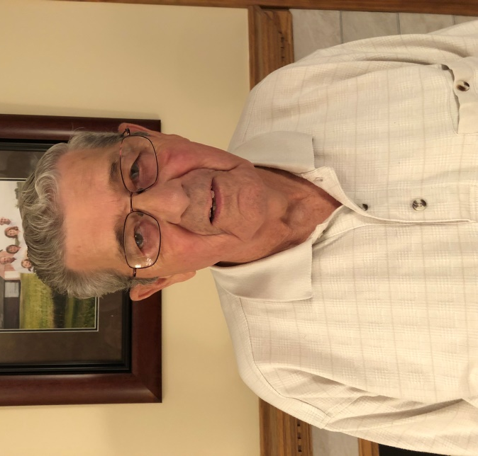

We are so glad you have decided to join our church!

Calendar
July 21 9:00 am - 2:00 pm VBS
July 22 VBS Sunday
July 22-28 Jacqueline at Chi Rho Camp
August 5 Pastor Jacqueline’s Installation Service & pot-luck lunch
August 19 8:30 am Pancake Breakfast (compliments of the Church Men) & All Church Sunday School
August 26 Back-to-School Sunday: Pot-luck lunch & Family Activities
Sept 1-3 Popcorn Festival with the FCC booth
Sept 2 10:00 am Popcorn Worship at the Park (no worship at church that day)
Oct 19-20 Regional Assembly
Nov 3 Thrive! workshop
Nov 10-16 Mission Trip to Little Rock, Arkansas

August Birthdays & Anniversaries

1 Bill Weaver 15 Cathy Sherwood
3 Rex Bland 16 Norma Butcher
4 Sheila Bland 16 Randy Rue
4 Curtis Carver 18 Jada Peterson
5 Lee Ann Gilbert 21 Dori Gowin
5 Bill & Sandy Weaver 22 Kenny Shobe
7 Baili Patchett 22 Cheryl Stifal
10 Gene & Roberta Decker 26 Danny Simpson
11 Betty Wofford 26 Mike & Connie Roberts
11 Keith & Debi Sinclair 28 Brad & Peggy Hickox
12 Mike Roberts 28 Jeff & Tiffany Gowin
14 Shari Newlin
 | August 2018
Sun | Mon | Tue | Wed | Thu | Fri | Sat
 |  |  | 1  7:00 Board Meeting | 2 | 3 | 4
5  Jacqueline’s Installation Service | 6  9:00 MML  4:30 Boy Scouts  5:30 WW | 7 | 8 | 9  5:00 Red Hawk | 10 | 11  11:00-1:00  Cookout at Martin’s IGA
12  Last Sunday to collect Kleenex & Puffs | 13  9:00 MML  4:30 Boy Scouts  5:30 WW | 14 | 15 | 16 | 17 | 18
19  8:30 Pancake Breakfast (provided by Church Men)  All-Church Sunday School | 20  9:00 MML  4:30 Boy Scouts  5:30 WW | 21 | 22 | 23 | 24 | 25
26  Back to School Sunday & Family Lunch | 27  9:00 MML  4:30 Boy Scouts  5:30 WW | 28 | 29  6:00 Deacons Meeting  7:00 Elders Meeting | 30 | 31

