Casey First Christian Church (Disciples of Christ)
200 SE 8th St. · P.O. Box 303 · Casey, IL 62420
(217)932-2773 · cfcc@caseyfcc.org · www.caseyfcc.org
Rev. Jacqueline Morgan, Pastor · (217)549-0654

Sunday Services: 9:00 am Sunday School · 10:00 am Worship

To Know God-To Love God-To Serve God

SERVING SCHEDULE
 | Week 3/03/2019 | Week 3/10/2019 | Week 3/17/2019 | Week 3/24/2019 | Week  3/31/2019
ELDERS | Nina Meeker  Debi Sinclair | Cindy Stephen  Nina Meeker | Moe Wimbley  Ruthie Wimbley | Dan Winn  Sharon Durham | Nina Meeker  Debi Sinclair
ELDERS SHUT-INS | Nina & Debi
DEACONS | Brad Hickox  Charles Meeker  Cassie Ramsey | Sharon Richardson  Connie Roberts  Shellie Simpson | Kenny Shobe  Steph Shobe  Devan Smith | Cheryl Stifal  Jeanne Unzicker  Jeri Bland | Bill Brewer  Brad Hickox  Charles Meeker
PREP. COMM. | Brad & Charles | Sharon & Connie | Kenny & Steph | Cheryl & Jeanne | Bill & Brad
DEACONS SHUT-INS | Jeri & Bill
WORSHIP LEADER | Brad Hickox | Larry Patchett | Devan Smith | Jenny Winschief | Kathy Hayes
GREETER | Cassie & Owen Ramsey | Larry Patchett | Rose Peterson | Jerry Cutright & Chelsea Clapp | Ruthie & Moe
SOUND | Devan Smith | Brad Hickox | Ken Whitton | Chelsea Clapp | Michael Stephen
CHILDREN'S MESSAGE | Eleanor Markwell | Peggy Hickox
CHALLENGER REFRESHMENTS | Peggy Hickox | Eleanor Markwell | Cathy Sherwood | Debi Sinclair | Linda Stoneking
SERMON | Pastor Jacqueline | Pastor Jacqueline | Pastor Jacqueline | Pastor Jacqueline | Pastor Jacqueline
From the pastor’s desk…

Lent will start on Ash Wednesday, March 6 and ends on Holy Saturday, April 20. This is the season on the church calendar that takes on a journey towards Holy Week, which starts with Palm Sunday, followed by Maundy Thursday, Good Friday and Holy Saturday, to prepare us for Easter Sunday and the Easter Season.

Lent is a period of 40 days plus Sundays. During the last week of Lent, called Holy Week, we recall the last week of Jesus’ life, from the time he entered Jerusalem, through his last meal and death, to resurrection. Lent calls us to open ourselves up to the Holy Spirit and let the Spirit take up residence in our lives, in our hearts and in our souls. Often all those places are filled up with other things like schedules, negative thoughts and emotions, demands, and stuff. To make room for the Spirit in our lives we often need those 40 days plus Sundays to clean house and make room.

There are many ways to do this. Traditionally people have used this church season for fasting; eating less of the decadent foods we like, reminding us that all we really need is God’s presence in our lives. In recent years people have used this time of preparation in other ways to make room for the Holy Spirit in our lives, like adding spiritual practices, or fasting on negative behavior. There is no right or wrong way to prepare ourselves during the season of Lent.

This year as a church we have chosen the theme: Living Lightly. We invite you to get an empty box, put it somewhere in your home and every day pick something out of your home that is no longer useful to you, but is not trash, broken or in bad shape, something that could be useful to someone else, and put it in the box. As you decide every day what it is that you can live without, we also invite you to add a spiritual practice that is meaningful to you to add to your life, through which the Spirit can speak to you.

Spiritual practices come in many shapes. They can consist of devotional readings, a daily plan of Bible readings, prayer time, journaling, coloring, reflective time outside in nature, meditation, breathing exercises, physical exercises, ceremonies, rituals, healthy eating, giving, self-care, etc. Adding one thing to your life this Lent season that will connect you to the Holy Spirit, while at the same time unburdening yourself of the things that no longer serve you, will hopefully help you to prepare for the celebration of resurrection.

The treasures we no longer need can be dropped off at the church the week after Easter. We will have a community-wide Sharing of Our Treasures on April 27. May this season of Lent be meaningful to you and help you connect with the Spirit of God in new or old meaningful ways.

Blessings,
Jacqueline

Prayer Requests
Cathy Sherwood
Mike Sherwood
Keith Sinclair
Kay Smith
Taylor Stifal
Doris Taylor
Audria Truelove Family
Susie Weir
Bob William

Sue Hills
Brooks Leichty
Alicia Ortiz
Casey Overbeck’s cousin, Devon
Cindy Price
Randy Rue
Anna Schlacter
Jerry Self

Helen Allen
Brad Beasley
Bob Bluhm
Bennett Lee Clapp
Rachel Cutright
Dwight Ennis
Dale Finney
Rich Grafton
Lowell Hickox

Casey Health Care Heartland Active Military
Ruth Fitch Vera Ingle Brandon Blair
Helen Allen Daniel Daugherty
Simple Blessings Mitchell Markwell
Laura Snider
JOYS
Larry & Kay Smith – Celebrated their 60th Wedding Anniversary February 15th
Keygen Decker – Able to return to work March 1st
Patty & Brent Clapp – New Grandson
Kyleigh Decker – College Softball Team Won Tourney in Mexico
Jeri & Rex Bland – New Grandson
Bill & Sandy Weaver – New Great-grandson

Announcements & Upcoming Events

Bunko
Fun and games are back on Wednesday March 20th at 6:30 pm.
Join us for a Bunko night of games, fellowship and laughter.

Dinner & A Prayer for Women
March 13, 6:30-8:30 pm all women are invited to Lynda Graham’s home for Dinner & A Prayer:
511 Horseshoe Lane
This will be a time for informal fellowship around the table(s), devotion and prayer. All women are welcome – bring a friend. To make sure that there will be enough food, please look for the sign-up sheet in the Gathering Room and let us know you are planning to be there.

Board Retreat
We had a very productive Board Retreat last month. Your Board Members worked hard and with dedication on spiritual practices, educational information, and planning events in the life of the church for the coming year. One of our bulletin boards in the hallway has an annual calendar with the events that are already placed on the calendar. We invite you to take a look and mark things you would enjoy on your personal calendar to save the date. It takes all of us together to enrich the ministry of this church, both inside and outside of our walls. With the work of our leaders at the Board Retreat we are making a great start.

Beyond the Broken Heart
The Grief support group as scheduled has been canceled and will be rescheduled soon.

March Free Meal
March 18 our church will be serving the Monday Free Meal. Look for the sign-up sheet to see how you can help out by bringing food or volunteering your time. On the menu is chicken casserole.

Monday Night Free Meal, March 18th, Sign-up sheet is in the Gathering Room
Please have the items at the church on Sunday, March 17th

Cream of Celery Soup (6 Cans) Shredded Cheddar Cheese (3#)
- Lynda Graham 1. Debi Sinclair 1#
- Lynda Graham 2. Linda Stoneking 1#
- Lynda Graham 3. Linda Stoneking 1#
- Lynda Graham Chicken Broth (12 Cups)
- Sharon Durham 1. Debi Sinclair 1 Box
- Sharon Durham 2. Linda Coleman 1 Box
Cream of Chicken Soup (6 Cans) 3. Linda Stoneking 1 Box
- Linda Coleman 4. Eleanor Markwell 1 Box
- Linda Coleman 5. Marsha Rue 1 Box
- Eleanor Markwell 6. Sharon Durham 1 Box
- Becky Sweeney 7. Shirley Fitch 1 Box
- Donna Nichols 8. Donna Nichols 1 Box
- Donna Nichols 9. Jeri Bland 1 Box
Large Jar of Red Pimentos (3 Jars) Lettuce (Shredded in Bag – 4 Bags)
- Becky Sweeney 1. Barb Decker 1 Bag
- Jeanne Unzicker 2. Peggy Hickox 1 Bag
- Jeanne Unzicker 3.
Green Peppers (8) 4.
- Sharon Roberts Carrots (Mini – 2 Bags) Workers 2:30-4:30
- Sharon Roberts 1. Linda Stoneking 1 Bag 1. Lynda Graham
- Sharon Roberts 2. Barb Decker 1 Bag 2. Debi Sinclair
- Jacqueline Desserts 3. Linda Coleman
- Jacqueline 1. Peggy Hickox 4. Linda Stoneking
- Jacqueline 2. Workers 4:30-6:30
- Jacqueline 3. 1. Becky Sweeney
- Jacqueline 4. 2. Peggy Hickox 5:15
5. 3.
6. 4.

Calendar
February 27 7:00 Elders Meeting
March 4 11:00 & 6:00 Serving from the Heart Study
March 5 10:00 Worship Team meeting
March 6 5:00-7:00 Ash Wednesday Prayer Stations
7:00 Board meeting
March 10 Daylight Savings Time
March 11 11:00 & 6:00 Lent Study
March 13 6:30-8:30 Dinner & A Prayer @ Lynda Graham’s home
March 14 5:00-8:00 Pancake Dinner Fundraiser
March 16 Regional event for women: Pray & Play @ FCC in Virden
March 17 Hymn Sing Sunday
March 18 11:00 Lenten Study
4:00-6:00 Free Meal served at our church
March 20 6:30 Bunco
March 23 12:30-2:30 Webinar: Empowering the Laity to Care for Pastors
March 24 March Madness Subs fundraiser
March25 11:00 & 6:00 Lenten Study
March 27 7:00 Elders meeting
March 31 Deacons meeting after church

MARCH 10TH MARCH 5TH, 1ST Baptist Church

MARCH 2019

2 – Lynda Graham 20 – Lance Patchett
4 – Karen Carver 21 – Janet Freeman
4 – Kay Smith 24 – Tiffany Gowin
4 – Sage Gilbert 26 – Jason Wimbley
7 – Jackson Hayes 26 – June Athey
8 – Colin Carver 27 – Dean Roberts
11 – Deb Decker 28 – Linda Coleman
12 – Rebecca Daugherty 28 – Sara Athey
15 – Curt & Jane Wheat 30 – Travis East
17 – Rose Peterson 31 – Liliana Freeman
18 – Fred Bright 31 – Ken & Brenda Whitton
18 – John Graham

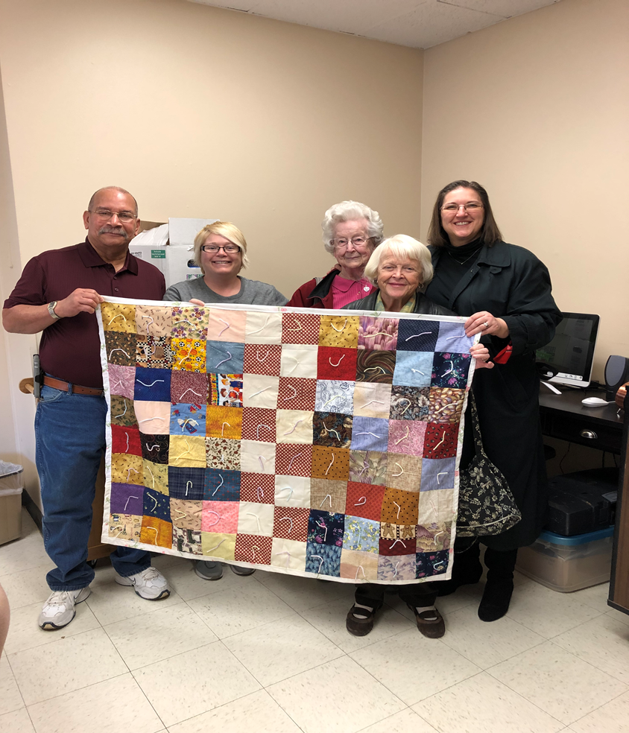

Delivered Lap Robe Quilts to Evergreen Nursing Home in
Effingham today, February 26, 2019.
Pictured are; Moe Wimbley, Evergreen employee, Dorothy Stice, Sharon Roberts and Pastor Jacqueline.

 | March 2019
Sun | Mon | Tue | Wed | Thu | Fri | Sat
 |  |  |  |  | 1  8:30–2:30 pm  Preschool Roundup | 2
3 | 4  9:00 am MML  11:00 am or 6:00 pm  Bible Study  Serving from the Heart | 5  10:00 am  Worship Team | 6  Ash Wednesday  5:00-7:00 pm  Prayer Service  7:00 pm Board Meeting | 7 | 8 | 9
10  Daylight Savings Time | 11  9:00 am MML  11:00 am or  6:00 pm  Lent Study | 12 | 13  6:30 pm Dinner & A Prayer @ Lynda Graham’s Home | 14  Fund Raiser  Pancake & Sausage Supper  5:00-8:00 pm | 15 | 16  Pray & Play Regional for Women  1:00-5:00 pm  Virden, IL
17  Hymn Sing Sunday | 18  9:00 am MML  11:00 am or  6:00 pm  Lent Study  4-6 pm Free Meal Monday | 19  Newsletter | 20  6:30 pm Bunko | 21 | 22 | 23  Webinar  12:30-2:30 pm  Empowering the Laity
24  Sale of Subs for March Madness after church | 25  9:00 am MML  11:00 am or  6:00 pm  Lent Study | 26 | 27  7:00 pm Elders Meeting | 28 | 29 | 30
31  Deacons meet after church |  | MML – Monday Morning Ladies  FH – Fellowship Hall

